

Andy Puddicombe, co-founder of headspace says, “By introducing mediation and mindfulness at an early age, not only can we build on this and help nurture their mind development, but we are also making meditation simple and accessible”

**References**

[**https://harshadapathare.com/my-quotes/meditation-quotes/#jp-carousel-17864**](https://harshadapathare.com/my-quotes/meditation-quotes/#jp-carousel-17864)

[**https://www.healthlinkbc.ca/health-topics/aa141106spec**](https://www.healthlinkbc.ca/health-topics/aa141106spec)

[**https://blog.bufferapp.com/how-meditation-affects-your-brain**](https://blog.bufferapp.com/how-meditation-affects-your-brain)

[**https://www.headspace.com/meditation/kids**](https://www.headspace.com/meditation/kids)

“Mindfulness Meditation.

For You and Your Little One.”



***Feel Better* Learn Better *Sleep Better***

During a day, a child can be completely overwhelmed socially, emotionally and academically.



Meditation calms the mind, brings stillness to the body and awareness to our thoughts.

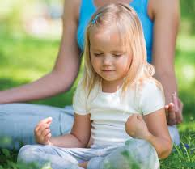

“We do not need any particular place or time to meditate but only mindfulness”.



**Is Your Family Life becoming too busy?**

Work, daycare, sports, time for family and friends, are all mixed in with the hassle and bustle, stress and tiredness, high emotions and fatigue of a busy family. As parents we want to give the best care and support we can give to our children. Now is the time to try mindfulness mediation with your child.

**What is Meditation?**

“Meditation is the practice of focusing your attention to help you feel calm and give you a clear awareness about your life”

**Meditation Techniques:**

Guided mindfulness meditation can be practiced through breathing exercises, visualization (breathing in, while smelling a flower, breathing out while blowing out a candle), walking with a purpose (what do you see, hear, smell, place a small object on top of the head), or balance pose (yoga treepose) for a young child. Five minutes a day is all that is needed to start this new journey.



**Why Meditate?**

Mindfulness meditation gives your child the tools to be present in the moment, to learn about their thoughts, feeling, and images with in their mind or sounds surrounding them, creating a positive effect on their overall health.

**Can Meditation Clam a Child’s Brain?**

The answer is yes! “In the image below you can see how the beta waves (shown in bright colors on the left) are dramatically reduced during meditation (on the right).”

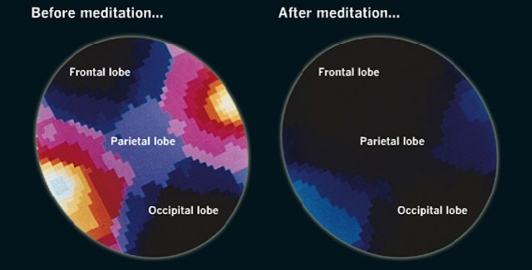

Mediation can also reduce stress, control anxiety, fights disease and improve sleep while balancing your child’s mental**,** physical and emotional well being**.**



**Benefits for your child when practicing mediation:**

1. Being in the present moment.
2. Improving focus and attention span
3. Managing mind/body connection.
4. Learning patience.
5. Having more energy.
6. Understanding emotions.
7. Increasing memory skills.
8. Enhancing self awareness for themselves and others.
9. Releasing negative thought and behaviours.
10. Having a positive outlook on life.

**Meditation for Beginners:**

1. Choose a quiet place to sit or lie comfortably.
2. Close your eyes.
3. Breath naturally, inhale through your nose, exhale through your mouth.
4. Focus your attention on your breath and how your body moves and feels.
5. Set a gentle alarm to end practice.