  - Mindfulness Meditation
Fun Brain Facts

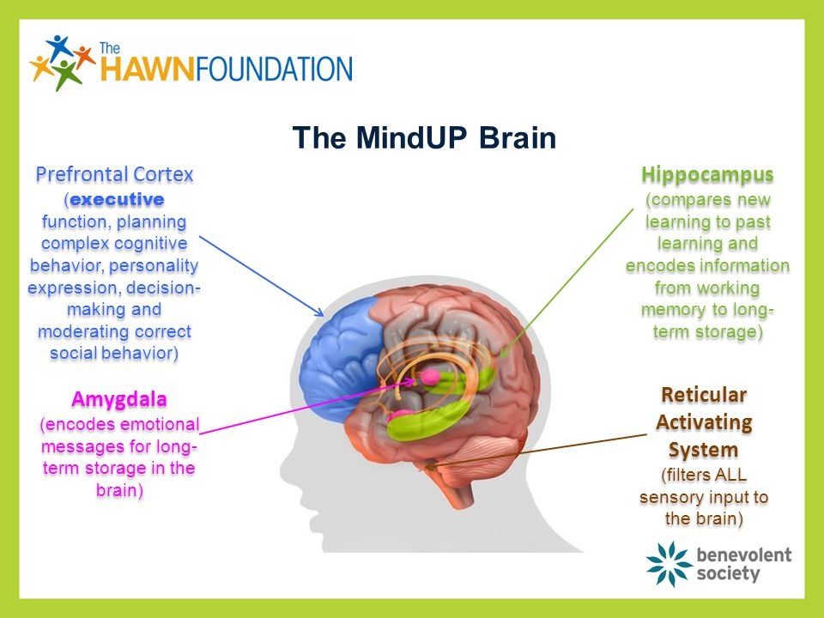

  - Mindfulness Meditation
Fun Brain Facts

PFC  WISE LEADER | *Right behind our forehead  *Helps us make good choices
Amygdala  SECURITY GUARD | *Warns us of danger  *Keeps us safe  *Helps us express our feelings
Hippocampus  MEMORY KEEPER | *Stores memories  *Helps us remember our friend’s names

